**CS160 Web Programming – Python**

**HP02 Functions and Lists**

8/19/2019 Developed by Apiwat Chuaphan

9/19/2019 Reviewed by Tuan Khai Tran & Kim Nguyen

Center for Information Assurance (CIAE) @City University of Seattle (CityU)

 

**Before You Start**

* The directory path shown in screenshots may be different from yours.
* Some steps are not explained in the tutorial**.** If you are not sure what to do:
  1. Consult the resources listed below.
  2. If you cannot solve the problem after a few tries, ask a TA for help.

**Learning Outcomes**

Students will be able to:

* Create functions in Python
* Understand the List Data Type in Python
* Write a Python program with Functions and Lists

**Resources**

* [Automate the Boring Stuff with Python](https://login.proxy.cityu.edu/sso/skillport?context=89288)

**Preparation**

1. Open the VS Code and open the amazon-apprenti-2019-2/CS160/YOURNAME directory

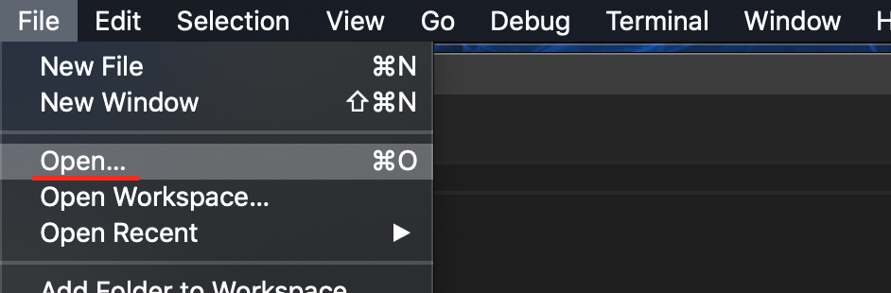

Note: change YOURNAME to your real name. If you do not have the CS160 or YOURNAME folder, please create them under the amazon-apprenti-2019-2 folder.

1. Create a Module2 directory under YOURNAME directory. (If this directory exists, skip this step.)

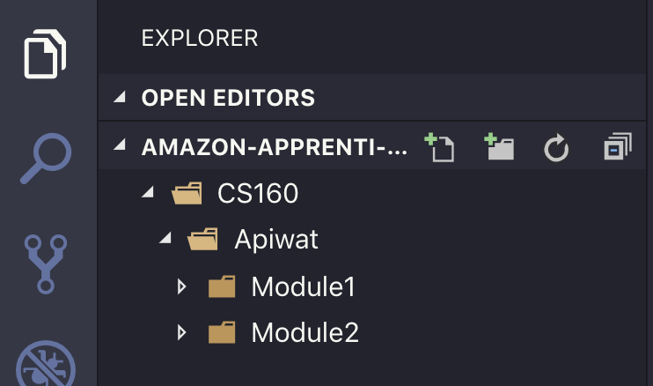

Click the Add folder icon and type “Module2” for the folder name

**Python Functions**

A function is a set of statements that take inputs and perform specific computation and produces output. Python provides several built-in functions such as print(). You can create one which is called user-defined functions.

1. Let’s create a simple function to print a text and call it with a string argument. Create *my_func.py* file and type the following code

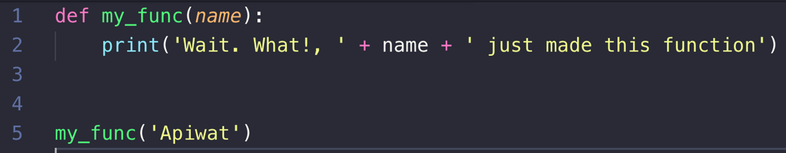

1. Run the file in the terminal by typing “**python**” followed by the name of the file into VSCode terminal. The result will look something like this.



1. Continue on with something more fun. Create a function to see what color represents your birthday and save it as *color_day.py*

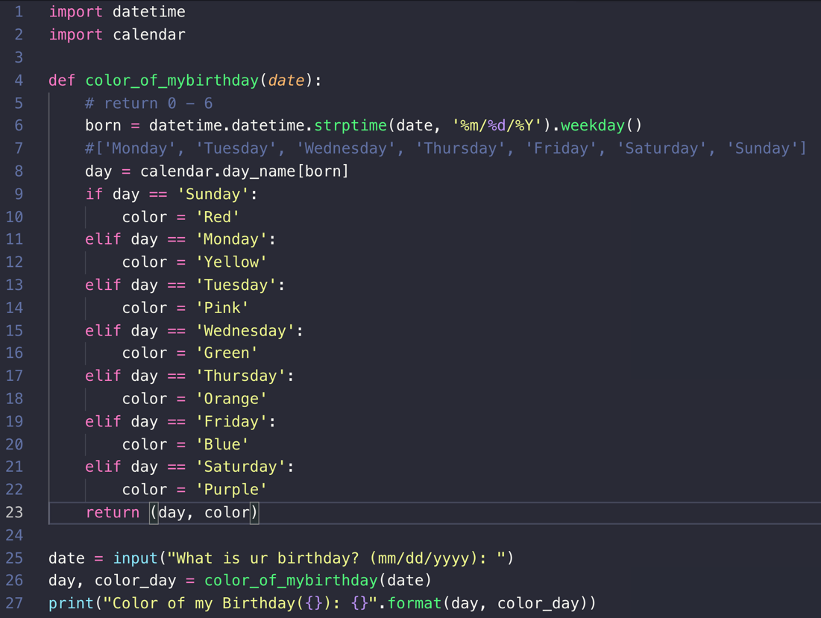

The output should look something like this.

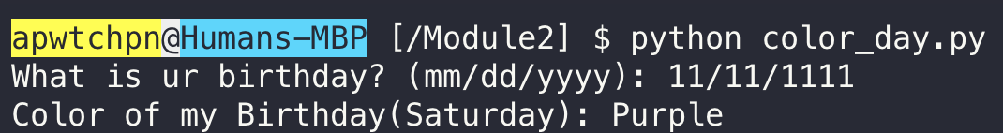

**Lists**

Lists contain multiple values in an ordered sequence and is mutable (can be changed). Let’s create a *list_method.py* file and write a code to create a list looks like this.

backpack = ['book', 'laptop', 'pen', 'banana', 2, True]

Let’s use some built-in list methods.

1. Do not forget the keys when you leave home, lets add “keys” item into the list by adding the following code. Then run to see if the “keys” has been added.

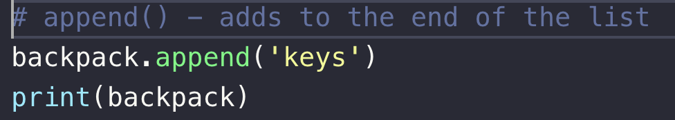

Run the code to see if the “keys” has been added.

Your backpack now has the keys.



1. Let’s add something more, but this time adding new item to any index in the list with **insert()** method. Add this code before the print statement.

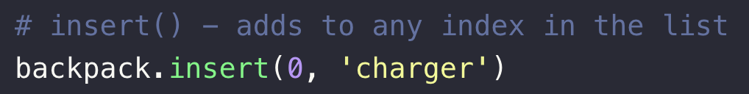

Your backpack now has the charger.



1. Now, the ‘book’ is too heavy. Let’s take it out of the backpack.

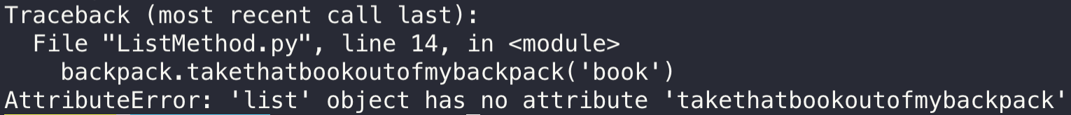

Oops! I got an error message. Can you help me **remove** the **“book”** item out by using the built-in method? Result after removing the book will look like this.



1. Write a function that replaces any negative numbers in the list with positive ones. Type the code below and save it as replace_negative.py

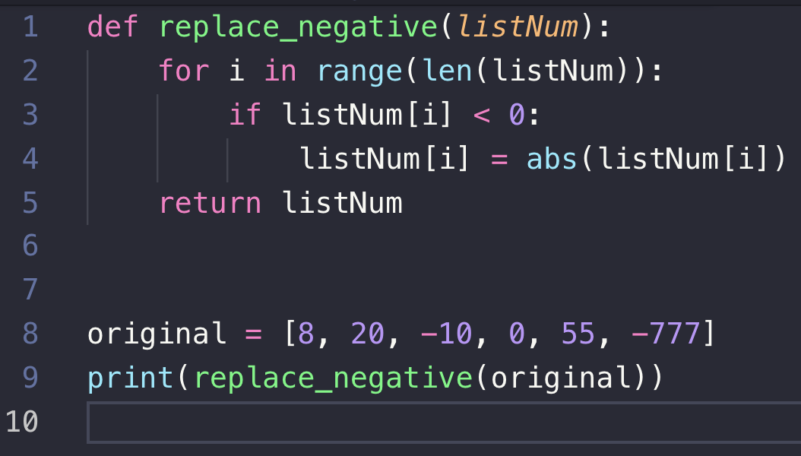

The result will look identical to this.



1. **List comprehension** refers to a short and concise way to construct new sequences. Print only even number using comprehension. Instead of writing a whole function to put only even number, we can write it in one line

input_list = [1, 2, 3, 4, 4, 5, 6, 7, 7]

output_list = [item for item in input_list if item % 2 == 0]

**Tuples**

The tuple data type is similar to list, except tuples are typed with parentheses and it is immutable which cannot be modified, appended, or removed.

1. Create a *tuple.py* file and define a tuple with multiple data types and try to modify the grade by assigning 4.0 value to item at index 1 which is 2.0

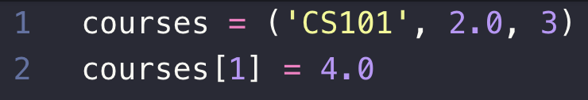

Note that you will get error message like this because Tuples can’t be modified unlike List

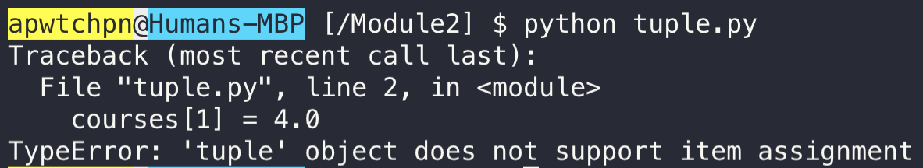

1. Create a *sort_tuple.py* with the following code to sort tuples by its first value.

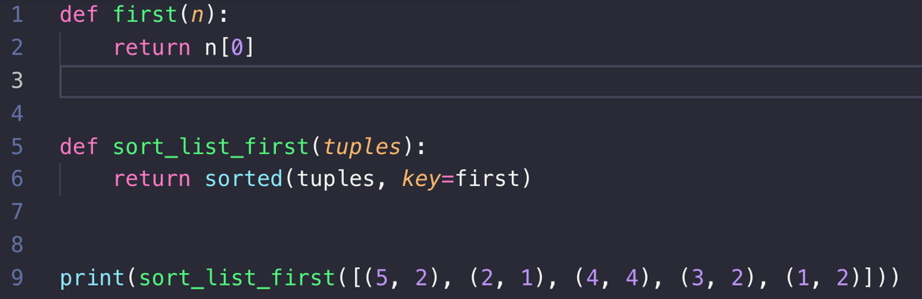

Output will be sorted.



**Push your work to GitHub**

Run the following commands to push your work to the GitHub repository:

Open the terminal from the VSCode by hitting the “control” + “~” key and type the following command:

>>> git add .

>>> git commit -m “Submission for Module 2”

>>> git push origin YOUR_BRANCH_NAME

Note: you should change the YOUR_BRANCH_NAME to your own branch name. It should be firstname-lastname (e.g. maria-gracia).

If you cannot remember, run the command “git status” to check.

**Create a pull request**

* Go to the remote repository in GitHub
* Create a pull request